LOCH INSH - SKI HIRE

Date………………………….

Print Name ……………………………………………. Collecting Equipment on …………………………….. Return Equipment on ……………………..

Please complete this form and return it to our office

 |  |  |  |  |  |  | FOR STAFF USE ONLY
Name | Age | Ability | Height  cms | Weight  kgs | Shoe size | Ski Suit Size | Boots | Skis | DIN | Sticks | Helmet | Amount paid | Returned

Please read terms and conditions on back and sign on the back.

£100 SECURITY DEPOSIT WILL BE REQUIRED FOR ALL HIRES THAT LEAVE OUR SITE.

All equipment hired must be returned by the guest to whom it was issued.
Any loss will be charged for at replacement cost.
The return of items other than those issued will be treated as a loss.
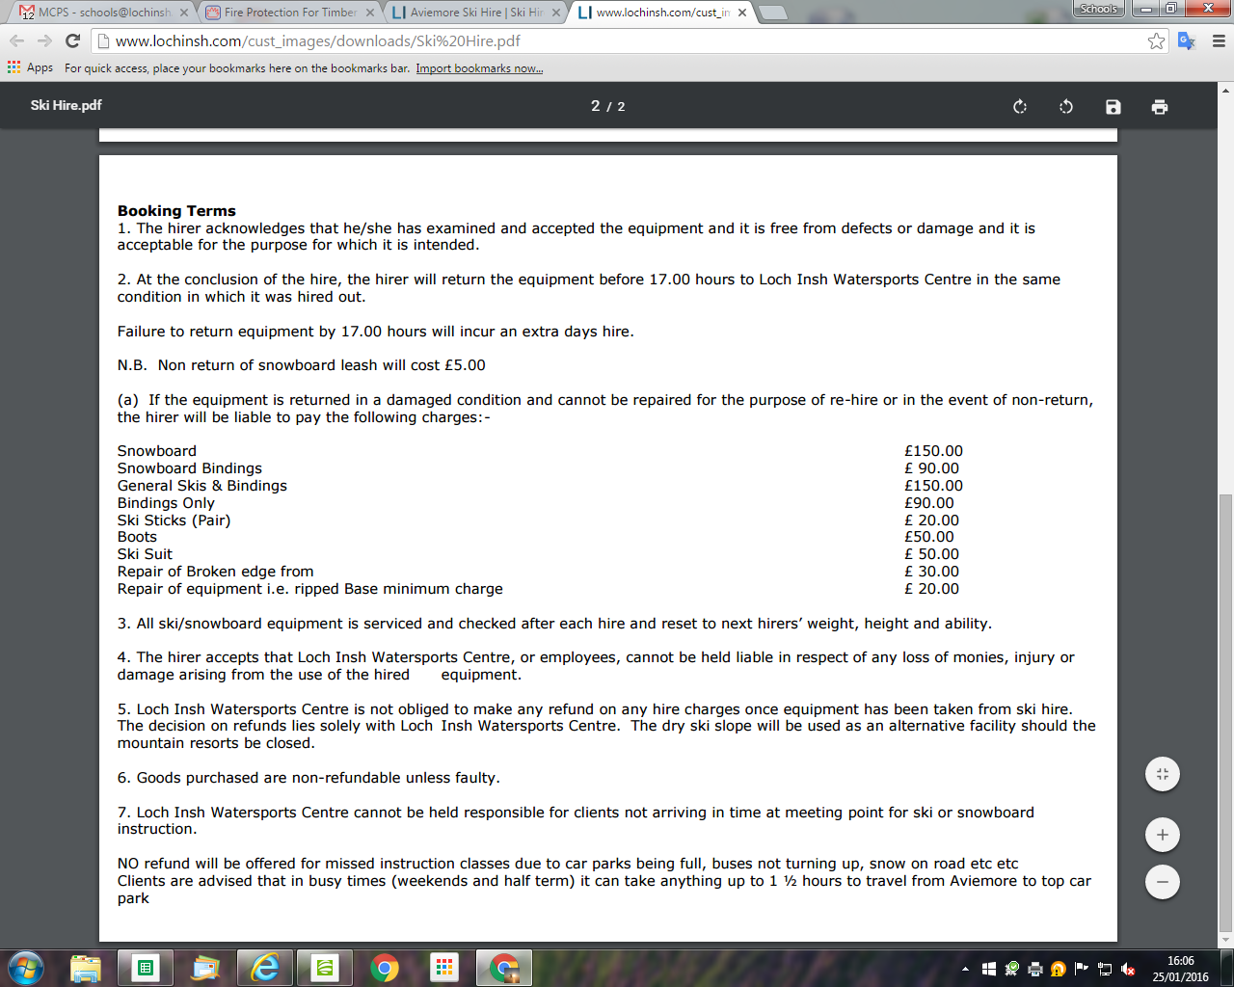

Please sign here in acceptance to the terms and conditions stated above...............................................................

